EXP 03 5G NR Throughput for QPSK–256QAM

AIM :
To calculate and compare 5G NR throughput for different modulation schemes (QPSK, 16QAM, 64QAM, 256QAM) using parameters such as bandwidth, subcarrier spacing, coding rate, and MIMO layers.
THEORY :
5G NR throughput depends on modulation order, coding rate, number of subcarriers, and MIMO layers.
Higher-order modulations carry more bits per symbol and provide higher data rates.
Throughput is estimated using:
$$T=(bitsPerSymbol)×N_{sub}×codeRate×MIMO_layers$$
Where:
- Bits per symbol: QPSK=2, 16QAM=4, 64QAM=6, 256QAM=8
- $N_{sub}=\frac{BW}{SCS}$
- Higher modulation → higher throughput.
PROCEDURE :
- Set 5G NR parameters: BW=100 MHz, SCS=30 kHz, code rate=0.85, MIMO layers=4.
- Compute total subcarriers using BW/SCS.
- Define modulation schemes and bits per symbol.
- Calculate throughput using the formula for each modulation.
- Display results and plot throughput vs. modulation.

PROGRAM :
clear; clc; close all;
%% 5G NR Parameters
BW = 100e6; % Bandwidth (100 MHz)
subcarrierSpacing = 30e3; % 30 kHz SCS
Nsub = BW / subcarrierSpacing; % Total subcarriers
codeRate = 0.85; % Example coding rate
MIMO_layers = 4; % 4x4 MIMO
%% Modulation Schemes & Bits per Symbol
mod_scheme = {'QPSK','16QAM','64QAM','256QAM'};
bits_per_symbol = [2 4 6 8]; % bps for each modulation
%% Throughput Calculation
throughput = zeros(1,length(bits_per_symbol));
for i = 1:length(bits_per_symbol)

bps = bits_per_symbol(i);

% Throughput formula:
% T = (bits per symbol) * (no. of subcarriers) * (coding rate) * (MIMO layers)
T = bps * Nsub * codeRate * MIMO_layers;

throughput(i) = T / 1e6; % Convert to Mbps
end
%% Display Results
disp('5G NR Throughput for Different Modulation Schemes:');
for i=1:length(mod_scheme)
fprintf('%s Throughput = %.2f Mbps\n', mod_scheme{i}, throughput(i));
end
%% Plot Throughput
figure;
bar(throughput,0.6);
set(gca,'XTickLabel',mod_scheme,'FontSize',12,'FontWeight','bold');
xlabel('Modulation Scheme'); ylabel('Throughput (Mbps)');
title('5G NR Throughput for QPSK–256QAM');
grid on;

OUTPUT :
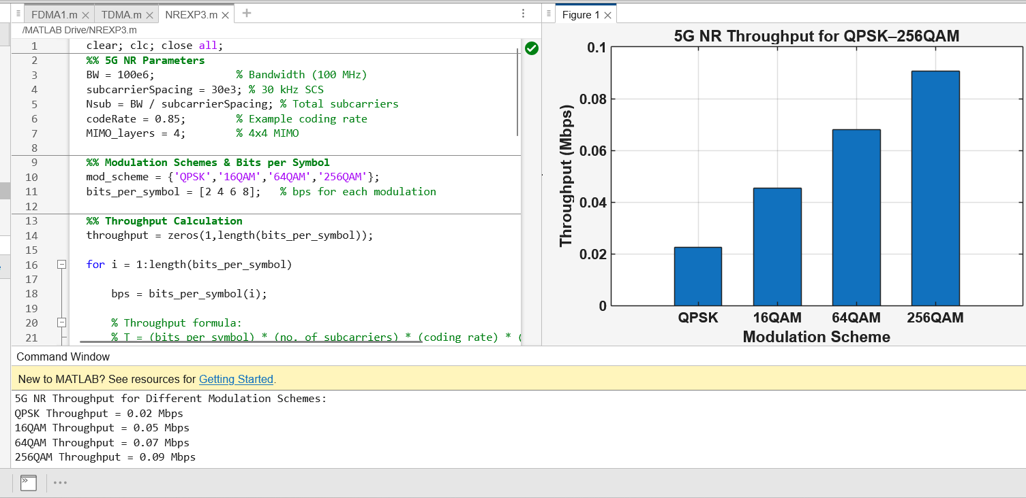

CONSOLE OUTPUT :
5G NR Throughput for Different Modulation Schemes:
QPSK Throughput = 0.02 Mbps
16QAM Throughput = 0.05 Mbps
64QAM Throughput = 0.07 Mbps
256QAM Throughput = 0.09 Mbp
CONCLUSION :
Throughput increases as modulation order increases. QPSK gives the lowest throughput, while 256QAM gives the highest. This shows that high-order modulation and MIMO significantly improve 5G NR data rates.

